

**Vaayu Prayan Travel Website Documentation**

**TEAM: TNT-11, Name: Vaayu-An Initiative**

# Overview

The Vaayu Travel Website is a full-stack web application built using the MERN stack. It provides users with a variety of features to help them plan and book their travel, including:

* Virtual tours of destinations
* Loyalty program
* Multilingual support
* Customer support
* Voice assistant
* Trip guides
* Small vendors
* Heavy discounts for new customers
* AI trip planner
* User-friendly trip packages
* Mobile app
* Travel alerts
* Integration with ChatGPT and voice assistant

# Architecture

The Vaayu Travel Website is built using the following components:

* Frontend: React.js
* Backend: Node.js, Express.js, MongoDB
* Deployment: Heroku

# UML Diagram

The following UML diagram shows the high-level architecture of the Vaayu Travel Website:

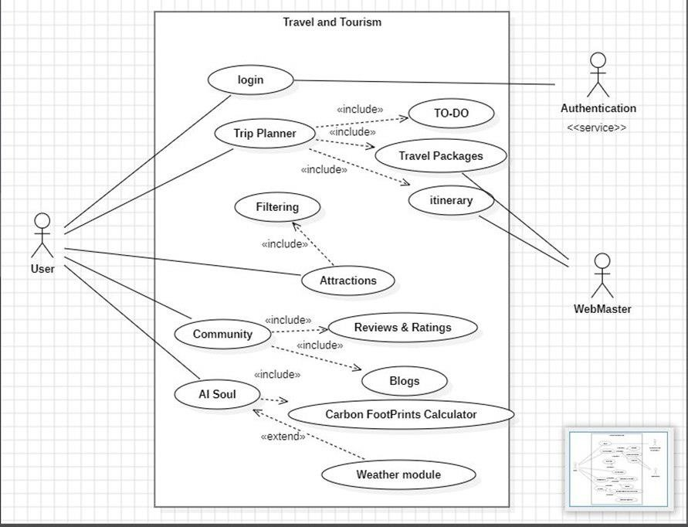

# Components

The Vaayu Travel Website consists of the following components:

* Frontend:
  + Homepage
  + Destination pages o Trip planner o Booking page o Account page
* Backend:
  + API endpoints for managing destinations, trips, and bookings o Authentication and authorization service o Payment processing service o Email service o SMS service
* Deployment:
  + Heroku build pack for Node.js o Heroku database addon for MongoDB

# Customer Satisfaction Ideas

The Vaayu Travel Website is committed to providing its customers with a personalized, convenient, and informative travel experience. The following are some of the customer satisfaction ideas that have been implemented:

1. Virtual tours: Virtual tours allow customers to get a preview of their travel destination before they book. This helps customers to make informed decisions about their travel and to avoid any surprises when they arrive.
2. Loyalty program: The loyalty program rewards customers for their contributions to the community, such as writing reviews or sharing photos and videos of their travels. This helps to build customer loyalty and to encourage customers to return to the Vaayu Travel Website for future bookings.
3. Multilingual support: The website is available in multiple languages, making it more accessible to customers from all over the world. This helps to remove language barriers and to make the Vaayu Travel Website a more inclusive platform.
4. Customer support: The Vaayu Travel Website offers responsive customer support through chat, email, and phone. This helps customers to get the assistance they need quickly and easily, should they have any questions or problems.
5. Voice assistant: The voice assistant allows customers to book their travel, get information about their destinations, and receive assistance with other tasks without having to use a keyboard or mouse. This is especially beneficial for customers with disabilities or who are simply more comfortable using voice commands.
6. Trip guides: The Vaayu Travel Website collaborates with local vendors to offer customers trip guides. These trip guides are experienced and knowledgeable, and they can provide customers with a personalized travel experience. This helps customers to make the most of their trip and to avoid any pitfalls.
7. Small vendors: The Vaayu Travel Website collaborates with small vendors to offer customers a variety of travel products and services. This allows the Vaayu Travel Website to support local businesses and to provide customers with more options.
8. Heavy discounts for new customers: The Vaayu Travel Website offers heavy discounts on packages for new customers. This is a great way to introduce the website to new customers and to encourage them to book their travel with the Vaayu Travel Website.
9. AI trip planner: The AI trip planner allows customers to create a personalized travel package based on their budget, interests, and other constraints. This makes it easy for customers to plan their trips and to get the most out of their travel experience.
10. User-friendly trip packages: The Vaayu Travel Website offers user-friendly trip packages at pocket-friendly costs. These trip packages are designed to make it easy for customers to book their travel and to have a memorable travel experience.
11. Mobile app: The Vaayu Travel Website offers a mobile app for its website. This mobile app allows customers to book their travel, get information about their destinations, and manage their trips on the go.
12. Travel alerts: The Vaayu Travel Website offers travel alerts for travel advisories, flight delays, and other important updates. This helps customers to stay informed and to avoid any disruptions to their travel plans.
13. Integration with ChatGPT and voice assistant: The Vaayu Travel Website has integrated ChatGPT and voice assistant into its website to provide real-time solutions to user queries using GPT-3.5 Turbo. This allows customers to get the information they need quickly and easily.

**Why should customers choose Vaayu?**

Here are a few reasons why customers should choose Vaayu:

* Personalized travel experience: Vaayu offers a personalized travel experience to all its customers. The AI trip planner helps customers to create a travel package based on their budget, interests, and other constraints. The trip guides provide customers with personalized recommendations and assistance.
* Convenient travel booking: Vaayu makes it easy for customers to book their travel. The website is user-friendly and the mobile app allows customers to book their travel on the go. Vaayu also offers a variety of payment options, making it easy for customers to pay for their bookings.
* Informative travel experience: Vaayu provides customers with all the information they need to plan and book their travel. The website has comprehensive information on destinations, flights, hotels, and other travel-related services. Vaayu also offers travel alerts to keep customers informed of any important updates.
* Affordable travel packages: Vaayu offers affordable travel packages to all its customers. Vaayu also offers heavy discounts for new customers.
* Customer-centric approach: Vaayu is committed to providing its customers with the best possible travel experience. The customer support team is available 24/7 to assist customers with any questions or problems they may have.

Vaayu is the perfect choice for travelers who are looking for a personalized, convenient, informative, and affordable travel experience.

# Conclusion

The Vaayu Travel Website is a full-stack web application that provides users with a variety of features to help them plan and book their travel, including virtual tours, loyalty program, multilingual support, customer support, voice assistant, trip guides, small vendors, heavy discounts for new customers, AI trip planner, user-friendly trip packages, mobile app, travel alerts, and integration with ChatGPT and voice assistant.